Fei Guo

1) Screen shot of Android Virtual Device running with main menu displayed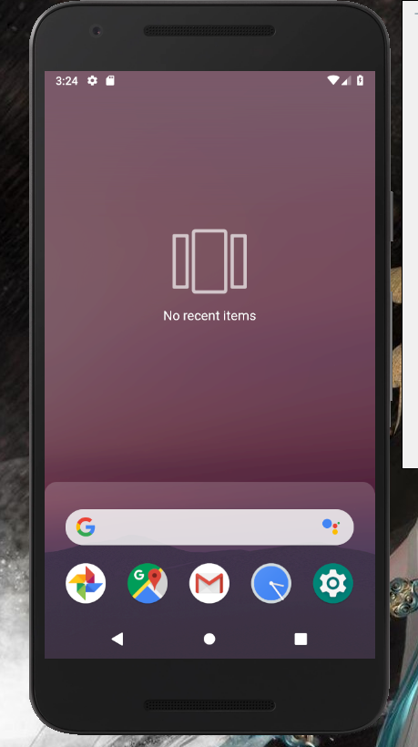

2) Screenshot of using virtual device to do something

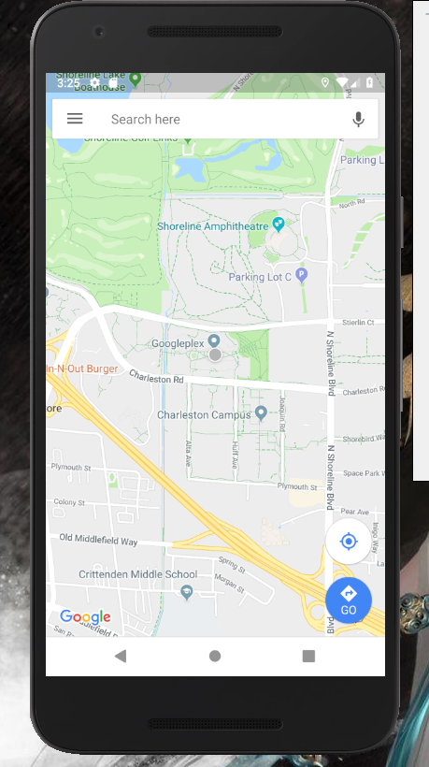

3) screenshot showing the virtual device running your first app

